All state prediction challenge (Kaggle).

Predict a purchased policy based on transaction history

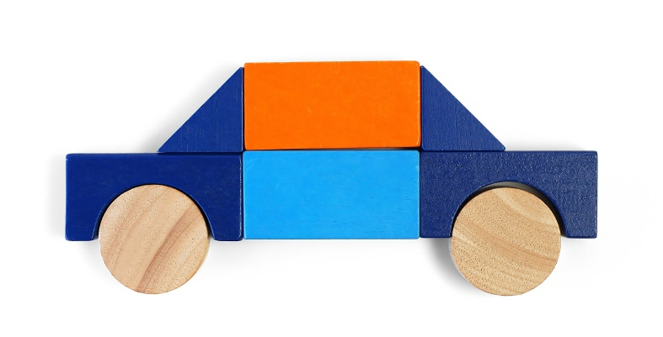

**The Brief:**

As a customer shops an insurance policy, he/she will receive a number of quotes with different coverage options before purchasing a plan. This is represented in this challenge as a series of rows that include a customer ID, information about the customer, information about the quoted policy, and the cost. Your task is to predict the purchased coverage options using a limited subset of the total interaction history. If the eventual purchase can be predicted sooner in the shopping window, the quoting process is shortened and the issuer is less likely to lose the customer's business.

Using a customer’s shopping history, can you predict what policy they will end up choosing?